**TUGAS UTS**

**MACHINE LEARNING**



**Oleh :**

**Muhammad Mirafuddin (F1B021136)**

**Muhammad Rafli (F1B021137)**

**Muh. Akmal Hidayatullah (F1B021132)**

**Alfan Satria Pratama(F1B020011)**

**TEKNIK ELEKTRO**

**FAKULTAS TEKNIK**

**UNIVERSITAS MATARAM**

**2025**

|  |  |  |  |  |  |
| --- | --- | --- | --- | --- | --- |
| Date | Precipitation | Temp_max | Temp_min | Wind | Weather |
| 2012-01-01 | 0 | 12.8 | 5 | 4.7 | drizzle |
| 2012-01-02 | 10.9 | 10.6 | 2.8 | 4.5 | rain |
| 2012-01-03 | 0.8 | 11.7 | 7.2 | 2.3 | rain |
| 2012-01-04 | 20.3 | 12.2 | 5.6 | 4.7 | rain |
| 2012-01-05 | 1.3 | 8.9 | 2.8 | 6.1 | rain |
| 2012-01-06 | 2.5 | 4.4 | 2.2 | 2.2 | rain |
| 2012-01-07 | 0 | 7.2 | 2.8 | 2.3 | rain |
| 2012-01-08 | 0 | 10 | 2.8 | 2 | sun |
| 2012-01-09 | 4.3 | 9.4 | 5 | 3.4 | rain |
| 2012-01-10 | 1 | 6.1 | 0.6 | 3.4 | rain |
| 2012-01-11 | 0 | 6.1 | -1.1 | 5.1 | sun |
| 2012-01-12 | 0 | 6.1 | -1.7 | 1.9 | sun |
| 2012-01-13 | 0 | 5 | -2.8 | 1.3 | sun |
| 2012-01-14 | 4.1 | 4.4 | 0.6 | 5.3 | snow |
| 2012-01-15 | 5.3 | 1.1 | -3.3 | 3.2 | snow |

Formula Untuk Perhitungan Probabilitas Setiap Atribut:

$$P\left(X_{i} | C\right)=\frac{Jumlah kemunculan nilai X_{i} dalam kelas C}{total jumlah data dalam kelas C}$$

***Drizzle* (1 hari)**

|  |  |
| --- | --- |
| * *Precipitation =* P(*precipitation* = 0 *| drizzle*) = $\frac{1}{1}$* *Temp_max* = P(*Temp_max >* 10| drizzle) = $\frac{1}{1}$ | * *Temp_min* = P(*Temp_min >* 5 *| drizzle*) = $\frac{1}{1}$* *Wind =* P(*wind > | snow*) = $\frac{1}{1}$ |

***Rain* (8 hari)**

|  |  |
| --- | --- |
| * *Precipitation =* P(*precipitation >* 0 *| rain*) = $\frac{7}{8}$* *Precipitation* = P(*precipitation* = 0 *| rain*) = $\frac{1}{8}$* *Temp_max* = P(*Temp_max* > 10 | *rain*) = $\frac{3}{8}$* *Temp_max =* P(*Temp_max* 5-10 *| rain*) = $\frac{5}{8}$ | * *Temp_min* = P(*Temp_min* > 5 *| rain*) = $\frac{2}{8}$* *Temp_min* = P(*Temp_min* 0-5 *| rain*) = $\frac{6}{8}$* *Wind =* P(*wind* > 4*| rain*) = $\frac{3}{8}$* *Wind =* P(*wind | rain*) = $\frac{5}{8}$ |

***Sun* (4 hari)**

|  |  |
| --- | --- |
| * *Precipitation =* P(*precipitation* = 0 *| sun*) = $\frac{4}{4}$* *Temp_max* = P(*Temp_max* 5-10| *sun*) = $\frac{3}{4}$* *Temp_max =* P(*Temp_max* > 10 *|sun*) = $\frac{1}{4}$ | * *Temp_min* = P(*Temp_min* < 0 *| sun*) = $\frac{2}{4}$* *Temp_min* = P(*Temp_min* 0-5 *| sun*) = $\frac{2}{4}$* *Wind =* P(*wind | sun*) = $\frac{4}{4}$ |

***Snow* (2 hari)**

|  |  |
| --- | --- |
| * *Precipitation =* P(*precipitation >* 0 *| snow*) = $\frac{2}{2}$* *Temp_max* = P(*Temp_max <* 5| *snow*) = $\frac{2}{2}$ | * *Temp_min* = P(*Temp_min* < 0 *| snow*) = $\frac{2}{2}$* *Wind =* P(*wind > | snow*) = $\frac{1}{2}$* *Wind =* P(*wind | snow*) = $\frac{1}{2}$ |

**Tabel Probabalitas**

|  |  |  |  |  |
| --- | --- | --- | --- | --- |
| *Precipitation* | *Temp_max* | *Temp_min* | *Wind* | *Weather* |
| $$\frac{0}{1}$$ | $\frac{1}{1}$ (High) | $\frac{1}{1}$ (High) | $\frac{1}{1}$ (High) | *Drizzle = $\frac{1}{15}$* |
| $$\frac{7}{8}$$ | $\frac{3}{8}$ (High) | $\frac{2}{8}$ (High) | $\frac{3}{8}$ (High) | *Rain = $\frac{8}{15}$* |
| $$\frac{0}{4}$$ | $\frac{1}{4}$ (High) | $\frac{0}{4}$ (High) | $\frac{0}{4}$ (High) | *Sun = $\frac{4}{15}$* |
| $$\frac{2}{2}$$ | $\frac{0}{2}$ (High) | $\frac{0}{2}$ (High) | $\frac{1}{2}$ (High) | *Snow = $\frac{2}{15}$* |

**Uji coba data**

**Drizzle**

|  |
| --- |
| P(drizzle)×P(Precipitation = 0∣drizzle)×P(Temp_max = High∣drizzle)×P(Temp_min = High∣drizzle)×P(Wind = High∣drizzle) $=$ $\left(\frac{1}{15}\right)x\left(\frac{1}{1}\right)x\left(\frac{1}{1}\right)x\left(\frac{1}{1}\right)x\left(\frac{1}{1}\right)= \frac{1}{15}$ $=0,0667$ ​ |

**Rain**

|  |
| --- |
| P(rain)×P(Precipitation = 0∣rain)×P(Temp_max = High∣rain)×P(Temp_min = High∣rain)×P(Wind = High∣rain) $$=\left(\frac{8}{15}\right)x\left(\frac{1}{8}\right)x\left(\frac{3}{8}\right)x\left(\frac{2}{8}\right)x\left(\frac{3}{8}\right) = \frac{8}{15} ×\frac{1×3×2×3}{8^{4}} = \frac{8}{15} × \frac{18}{4096} = 0,00234$$ |

**Sun**

|  |
| --- |
| P(sun)×P(Precipitation = 0∣sun)×P(Temp_max = High∣sun)×P(Temp_min = High∣sun)×P(Wind = High∣sun) $=$ $\left(\frac{4}{15}\right)x\left(\frac{4}{4}\right)x\left(\frac{1}{4}\right)x\left(\frac{0}{4}\right)x\left(\frac{0}{4}\right)= 0$ ​ |

**Snow**

|  |
| --- |
| P(snow)×P(Precipitation = 0∣snow)×P(Temp_max = High∣snow)×P(Temp_min = High∣snow)×P(Wind = High∣snow) $$=\left(\frac{2}{15}\right)×\left(0\right)×\left(0\right)×\left(0\right)×\left(\frac{1}{2}\right)=0$$ |

Proses Pembentukan *Node* akar

1. **Hitung Nilai Entropy**

Rumus *Entropy*:

*Entropy*(S) $=\sum_{i=1}^{n}{Pi}.\log{2(Pi)}$

$Pi$ adalah proporsi dari masing-masing kelas cuaca

* Jumlah total data = 15 hari
* Kategori *Weather* terdiri dari:
* Drizzle = 1 hari
* Rain = 8 hari
* Sun = 4 hari
* Snow = 2 hari

Hitung proporsi:

* Pdrizzle $= \frac{1}{15}$
* Prain $= \frac{8}{15}$
* Psun $=\frac{4}{15}$
* Psnow $= \frac{2}{15}$

Hitung Entropy:

*Entropy*(S) $= -\left({1 \atop 15}log2\frac{1}{15}+\frac{8}{15}log2\frac{8}{15}+\frac{4}{15}log2\frac{4}{15}+\frac{2}{15}log2\frac{2}{15}\right)$

$= -(0.0667.\log{2}(0.0667)+0.5333.\log{2(0.5333)+0.2667)+0.1333.\log{2(0.1333))}}$

$=$ − (0.0667⋅(−3.907)+0.5333⋅(−0.905)+0.2667⋅(−1.907)+0.1333⋅(−2.906))

$=$ −(−0.2606−0.4826−0.5087−0.3875)=1.6394

1. **Perhitungan Gain (Information Gain)**

Rumus :

Gain(A) = *Entropy*(S) $\sum_{i=1}^{n}{ }\left(\frac{S_{i}}{S}×Entropy(S_{i}\right)$

Gain median Precipitation =1.3

* $≤ 1.3 : 6$ data (drizzle, rain, rain, sun, sun, sun) = Entropy =1.459
* $> 1.3 : 9$ data (rain, rain, rain, rain, rain, sun, snow, snow) = Entropy =1.532

Gain =1.638 - $​\left(\frac{6}{15}\right)×1.459+\left(\frac{9}{15}\right)x1.532$

= 1.638 - (0.584+0.918 = 0.488

Gain median temp_max = 22.5

* $≤ 22.5 : 7$ data (rain, rain, sun, sun, snow, drizzle, sun) = Entropy =1.556
* $> 22.5 : 8$ data (rain, rain, rain, snow, sun, sun, sun, rain) = Entropy =1.406

Gain =1.638 - $​\left(\frac{7}{15}\right)×1.556+\left(\frac{8}{15}\right)x1.406$

= 1.638 - (0.726+0.750)

= 1.638 – 1.476 = 0.162

Gain median temp_min = 14.0

* $≤ 14.0 : 9$ data (rain, rain, snow, snow, sun, rain, drizzle, sun) = Entropy =1.503
* $> 14.0 : 6$ data (sun, sun, sun, rain, rain, sun) = Entropy =1.459

Gain =1.638 - $​\left(\frac{9}{15}\right)×1.503+\left(\frac{6}{15}\right)x1.459$

= 1.638 - (0.902+0.584)

= 1.638 – 1.486 = 0.152

Gain median temp_min = 5.2

* $≤ 5.2 : 10$ data (sun, sun, sun, drizzle, rain, rain, snow, sun, sun, rain) = Entropy =1.485
* $> 5.2 : 2$ data (sun, sun, sun, rain, rain, sun) = Entropy =1.371

Gain =1.638 - $​\left(\frac{10}{15}\right)×1.485+\left(\frac{5}{15}\right)x1.371$

= 1.638 - (0.99+0.457)

= 1.638 – 1.447 = 0.191

1. **Perhitungan Splitinfo**

Rumus Splitinfo:

SplitInfo(A) $\sum_{i=1}^{k}{ }\left(\frac{S_{i}}{S}×\log{2}\frac{S_{i}}{S}\right)$

Splitinfo(Precipitation)

* $≤ 1.3 : 6$ data
* $1.3 : 9$ data

SplitInfo = $-$ $\left(\frac{6}{15}\right)\log{2}\left(\frac{6}{15}\right)+\left(\frac{9}{15}\right)\log{2}\left(\frac{9}{15}\right)$

$=$ 0.4 $×$ $​\log{2}0.4+0.6 x \log{2}0.6$

= (0.4 $×$ ($-$ 1.322 + 0.6 $×(-737)$)

= $-(-$ 0.529 – 0.442) = 0.971

Splitinfo(Temp_Max)

* $≤ 22.5 : 7$ data
* $22.5 : 8$ data

SplitInfo = $-$ $\left(\frac{7}{15}\right)\log{2}\left(\frac{7}{15}\right)+\left(\frac{8}{15}\right)\log{2}\left(\frac{8}{15}\right)$

$=$ 0.467 $×$ $​\log{2}0.467+0.533x\log{2}0.533$

= (0.467 $×$ ($-$ 1.009+0.533 $×(-907)$)

= $-(-$ 0.513 – 0.483) = 0.996

Splitinfo(Temp_Min)

* $≤ 14.0 : 9$ data
* $14.0 : 6$ data

SplitInfo = $-$ $\left(\frac{9}{15}\right)\log{2}\left(\frac{9}{15}\right)+\left(\frac{6}{15}\right)\log{2}\left(\frac{6}{15}\right)$

$=$ 0.6 $×$ $​\log{2}0.6+0.4x\log{2}0.4$

= (0.6 $×$ ($-$ 0.737+0.4 $×(-529)$)

= $-(-$ 0.442 – 0.529)

= $-(-$ 0.971) $=$ 0.971

Splitinfo(Wind)

* $≤ 5.2 : 10$ data
* $5.2 : 5$ data

SplitInfo = $-$ $\left(\frac{10}{15}\right)\log{2}\left(\frac{10}{15}\right)+\left(\frac{5}{15}\right)\log{2}\left(\frac{5}{15}\right)$

$=$ 0.667 $×$ $​\log{2}0.667+0.333x\log{2}0.333$

= (0.6 $67×$ ($-$ 0.585+0.333 $×(-1.585)$)

= $-(-$ 0.390 – 0.528) $=0.918$

1. **Perhitungan Gain Ratio**

Rumus :

GainRatio(A) = $\frac{Gain(A)}{SplitInfo(A)​ }$

* Gain Ratio (Precipitation)

Gain = 0.488

SplitInfo = 0.971

GainRatio = $\frac{0.488}{0.971} =0.503$

* Gain Ratio (temp_max)

Gain = 0.162

SplitInfo = 0.996

GainRatio = $\frac{0.162}{0.996} =0.163$

* Gain Ratio (temp_min)

Gain = 0.152

SplitInfo = 0.971

GainRatio = $\frac{0.152}{0.971} =0.157$

* Gain Ratio (wind)

Gain = 0.191

SplitInfo = 0.918

GainRatio = $\frac{0.191}{0.918} =0.208$

Tabel Hasil Akhir Gain Ratio

|  |  |  |  |
| --- | --- | --- | --- |
| Atribut | Gain | SplitInfo | Gain Ratio |
| Precipitation | 0.488 | 0.971 | 0.503 |
| temp_max | 0.162 | 0.996 | 0.163 |
| temp_min | 0.152 | 0.971 | 0.157 |
| wind | 0.191 | 0.918 | 0.208 |

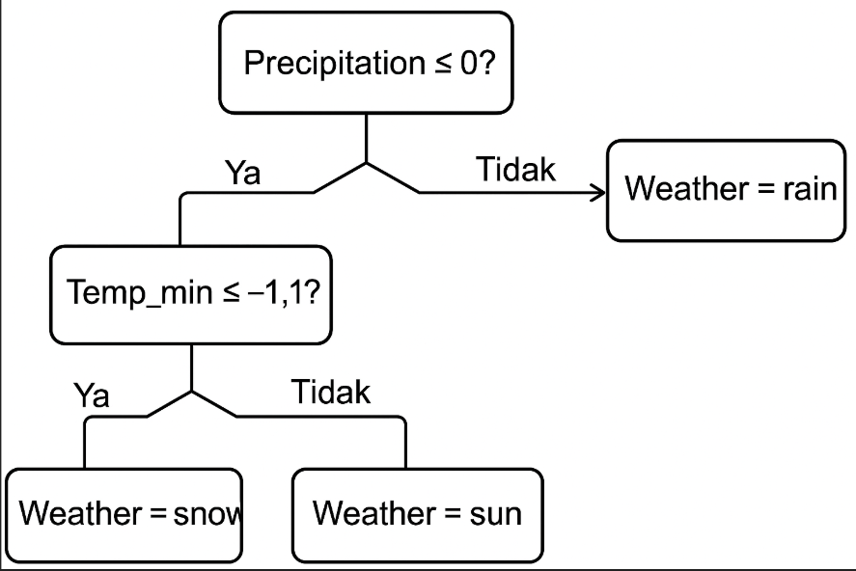**Pohon Keputusan**

Link google collab : Data Training dan Data Pengujian

https://drive.google.com/drive/folders/1NdGq0jO8dyuLHWCOCxRRediF0psRLgg-?usp=sharing